

Transportation management System (TMS)

Systems Analysis project

Abstract

According to this project, The TMS Company provides flexible transportation services for many clients to facilitate its client’s transportation requests. .This system will provide an effective minimum cost process and client’s satisfaction as well. In addition, all users are able to get various reports from this system based on their system’s using.

Omid aslan

Vanier College

Table of Contents

system planning 2

swot analysis3

constraints3

preliminary investigation overview3

perform fact-finding 3

feasible study3

preliminary investigation4

project management6

project triangle 6

risk management plan 6

System analysis8

data requirement8

data modeling10

object modeling15

transition diagram17

Activity diagram18

UML diagram19

data dictionary 21

System design25

platform consideration25

user interface26

data design consideration 26

System implementation27

structured diagrmas 29

System security30

**System** planning

**Mission statement and strategic plan**

***“TMS Company always considers respect and ease for every client and employee to go forward company’s productivity and effectiveness by increasing value added and keeping our company on the edge of technology.”***

1. **Business****Case**

**Company will design a software that provides an integrated Transportation Management System with regard to** **effective decision-making, reasonable costs, better routes as well as increasing client satisfaction**

1. **SWOT analysis**

**Strengthens**

* Company tends to keep its share in the transportation market with considering enhancement of IT knowledge
* Powerful database for future plan
* reduced labor costs
* Well- organized and consistent information about clients, carriers ,drivers as well as employers
* keep company in the right track

**Weakness**

* competitive market
* Lack of historical data for Key Performance Indicator(KPI) to be meaningful for decision making
* Number of carriers and their drivers
* Users’ IT knowledge

**Opportunities**

* TMS system will reduce human factors in the company
* Cloud computing potential
* Easy to expand and increase the size of system requests
* Easy to outsource and preserve company loyal clients
* Can be a part of ERP

**Threats**

* TMS System may be subjected to hackers’ attacks if it is implemented as a web application
* Gov. Decisions for transportation tariff.
* Drivers’ strike
* Unpredictable weather
* Rapid Fuel Fluctuation

1. **Constraints**
2. ***Internal factors***
3. *This system must be implemented within 2 months.*
4. *Number of IT experts and their desires*
5. *Budget and system implementation costs*
6. *IT infrastructure facilities*
7. *Intangible benefits cannot be evaluated easily.*
8. ***External factors***
9. *Number of carriers*
10. *Traffic and roads conditions.*

*\*There is not a specific committee to evaluate this business case. Therefore, we just cast this project into preliminary investigation*

1. **Preliminary Investigation Overview**
2. ***Opportunity****: TMS tackles the freight movement puzzle by handling single parcels to bulk commodities and everything in between. In most cases, the solutions oversee the movement of all inbound and outbound freight modes (including intermodal), at the domestic and international level. A TMS’ fleet management capabilities are usually focused on the shipper’s own transportation assets while its planning and execution functions monitor and track movements involving both inside and outside service providers. Finally TMS system can be a part of Supply chain management and it is able to facilitate the transportation process in ERP system.*
3. ***Define the Project Scope and Constraints* :**

*Shipping transportation fleets are terrestrial trucks, rail trains, air planes, maritime ships. Regarding these fleets, TMS system support all around the world and all merchandises unless they are part of forbidden consignments. On the other hand, destinations where shipping trade may subjected to high risk or government has enacted some restrictions such as sanction lawsuits are not allowed to be shipped. The system defines a communication scope for 4 type of users containing clients, providers, carriers and drivers*

***Must Do:***

* Being user-friendly regarding Graphical User Interface
* Getting different access to system with regard to authorized users
* Select the best shipping approach based on KPI (key performance indicator)
* Being able to issue variety of reports for clients, providers, carriers as well as drivers
* The provider will be able to possess his own fleet or outsource to other transportation companies.
* Prevent to store wrong input data regardless of user authority levels.
* Users will be able to store and update their related data.
* Implement a *Real time tracking Map* Module within Client, Provider and Carrier
* Display in graphical mode the real time coordinate of the *Driver* position

***Should Do:***

* The cost should be metric-based (mile; km), Weight-based, Cube-based or Unit-based with respect to the nature of the transported merchandise
* Presenting reports of the list of clients per type of industry

***Could Do:***

* *Upgrade system to be consistent with Web application*
* *Providing online training courses for relevant users.*
* *simulate the GPS position by the coordinate (x, y)*
* *Web-based report based on users’ demands.*
* *Design mobile application for users*

***Will not do:***

* *Understate client, carrier, providers staffs after running the system*
* *Not to understate drivers’ opinion*
* *Change OS platform after confirmation*

1. ***Perform fact-finding in the Transportation Management System***

*During internal survey considering all users, processes that result in TMS outcomes, describes in the following:*

*First of all a registered Client requests from transportation provider the best way of transportation of his goods based on Carrier cost, Client preference and other key performance indicators to be determined (KPI includes but not limited to operational goal [e.g. zero defects, customer satisfaction], shorter lead-time) from departure to destination. Then,* *the client will get the best suggested carrier from the provider based on the above KPIs. Sometimes clients need to change their orders so, they request to update, delete, or whatsoever with their orders. Providers gather all information about clients’ orders and process those orders with own criteria. They estimate invoicing cost of the transportation along with the chosen Carrier transportation information. Shipping transportation fleets are included terrestrial trucks, rail trains, air planes, maritime ships. These type of transportation related to carriers and their drivers. As long as the order is accepted by the provider, one of the carrier must be chosen with respect to KPI factors. The carrier is able to see the detail of the transported goods and get access to the shipping order created by the Provider showing the carrier information. Furthermore, the Carrier will be able to store and update information related to the chosen Carrier transportation info (Name of truck Driver and truck info, Name of Pilot and Air Plane info, Chef de Mission Railway and Train Number, Cargo Ship Name and Cargo Ship Captain Name and other info).* *Finally, drivers* *will be able to get access to the carrier order created by the carrier to see the detail of the transported goods and other information included in the carrier order created by the Carrier. The Driver will be able also to enter other information to be linked to the carrier order such as Real time transportation tracking simulating GPS coordinates reading, sending of transport alerts to Carrier to be reported to client if any (delay, accident, non-forecast stops. Since Real time transportation tracking are updated by drivers, other users including clients, providers and carriers can follow the merchandise having been shipped.*

1. ***Analyze Project Usability, Cost, Benefit, and Schedule Data***

*Any client who likes to reduce his or her cost of shipment can use this system. TMS project can provide many information about receiving time, tracking commodities and so on.*

*Carrier companies also can use and benefit from this system because it reduces many conflicts such as lack of vehicles or drivers absents. In addition of time and cost saving, TMS system will provide much relevant information for all users to determine what they need to do in the proceeding future. The cost of TMS project depends on the size of the project. This means that if it is implemented by web technologies and providers want to perform cloud computing structure, they should consider one of service providers such as IBM, Amazon or Microsoft Azure and etc. Therefore, the first estimated cost of TMS project is around 100000 $. Finally, project schedule data includes define a user log in the very beginning and every actor module must be completed afterward. These processes will be explained in project management in detail.*

1. ***Evaluate Feasibility***

*There are many reasons that TMS project is worthwhile and it is feasible .There are some reasons that I enumerate them:*

* *Since computerized TMS project considers time saving, less conflict and reduce fuel consumption, TMS definitely affects value added positively.*
* *The system will serve all users better and they will not be upset when they work with this system.*
* *This project seems to be profitable because it needs few equipment in office and its employees probably are not be more than 10 person as well.*
* *As long as this project runs, it can cover its cost within 4 months unless the marketing team cannot attract many customers.*

1. ***Present Results and Recommendations to Management***

*Shortly after the project finished, it may be a good decision to start a training course especially for drivers and carriers. This is because, if they are not friendly with the system, they are not going to lessen shipment time and it causes many unwanted result which can decrease clients’ trust.*

1. **Feasibility study**
2. *Operational*

* *Stakeholders support this project because it meets the strategic plan and mission milestone.*
* *This project is automated system.*
* *TMS system is fast and reliable and it can save all users time and improve productivity and effectiveness.*
* *Lessen wasting papers based on reduction of human errors and storing data in data base.*

1. *Economic*

**COST**

* *Regardless of desktop or web application, TMS system has implementation training and infrastructure costs. If we consider web application, TMS need could computing expenditure.*
* *Extra cost may be considers for coordinator office including some office and computer equipment.*
* *Software developers cost to implements this project.*

**BENEFIT**

* *All users are able to see their profiles and keep tracking the shipping processes in the system from beginning to the end.*
* *Users will be notified whether by emails or text messages about their orders.*
* *Paper consumption reduces noticeably so that this approach helps to save green.*
* *With this system, shipping methods will be considerably customized for clients.*
* *All users can navigate between their payments and other desire reports.*
* *With a real time navigation system, drivers and carries are going to experience less conflicts.*
* *Providers are able to upgrade the key performance indicator throughout user’s feedback in order to improve system performance.*
* *Transportation management system being Computerized plays a significant role to achieve long-term targets in every transportation company*
* *Stay in the edge of technology and being competitive in the related market*
* *Being loyal to Environment sustainability by reduction of paper usage.*

1. *Technical*

* *Whereas internet is the mainstay and web technology plays a significant role in TMS, web infrastructure such as web server, application server must be considered.*
* *Every company must have local and wide access to the system so, local network should be implemented. Every company should buy some facilities like switches, routers as well as PCs*
* *At least one Antivirus must be considered*

1. *Schedule*

* *Regarding to the course due date, we must fulfill this project within 2 months.*

1. **Project Management (MS project)**
2. Project Planning

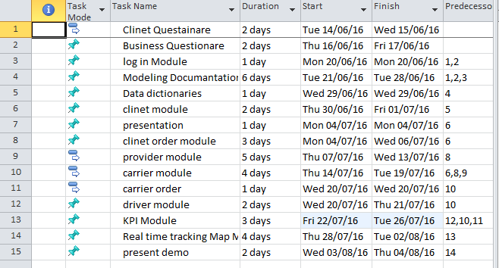

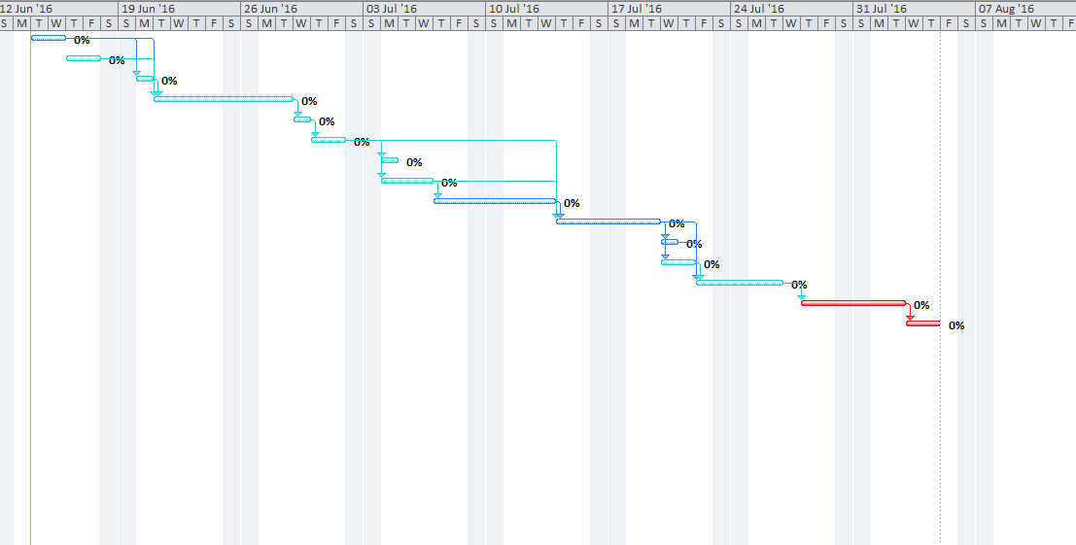

1. Project Scheduling

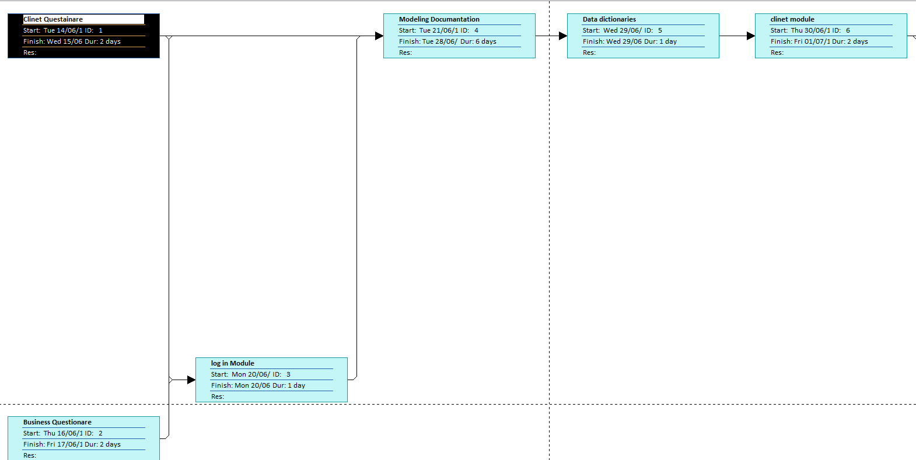

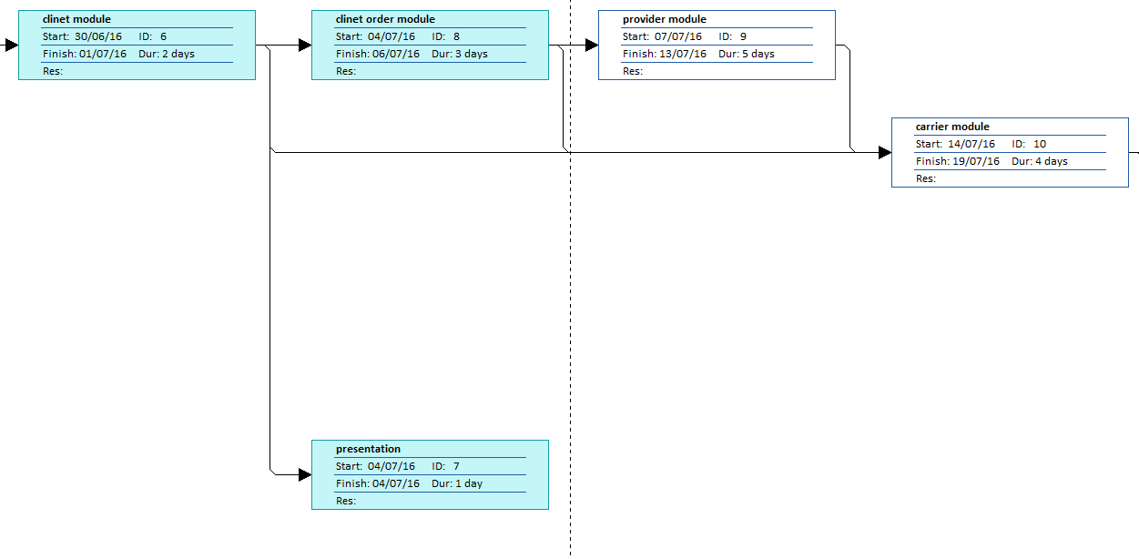

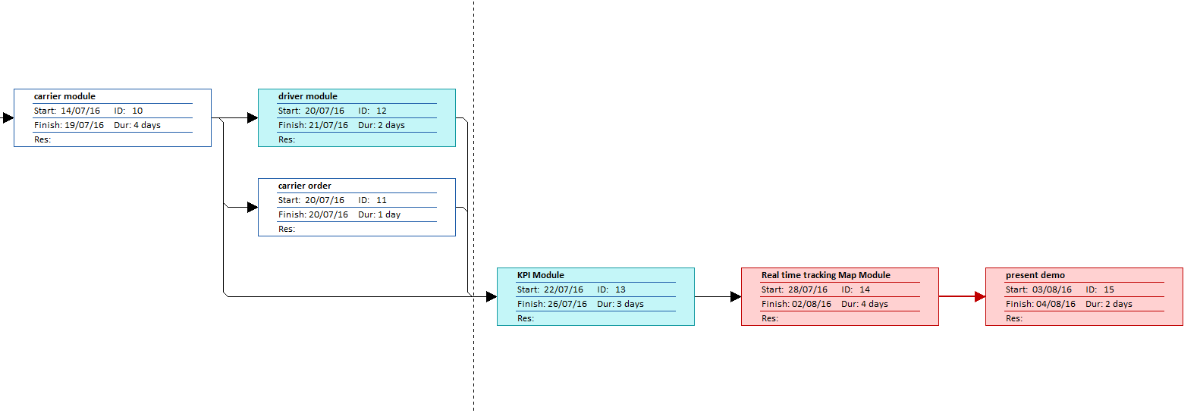

1. Project triangle
2. **Time** : According to project management section total time for this project is ----days
3. **Cost**: Considering the fact that this project needs minimum 4 PCs, one printer, an infrastructure for database, software developing team, cloud computing reserve space, antiviruses, and a specific office to implement this project, it will cost near to 100 thousand dollars.
4. **Scope**: From optimistic point of view, automated Transportation System plays a significant role to reduce delay, show beautiful reports, lessen conflicts, decrease human factor, save money for both carriers and clients

However, the very project may encounter with some problems such as difficult implementation or unwanted project cost like increasing rental place or programmers’ absents. In the worst situation, TMS project may last 1 month more than project schedule. In fact, the cost of project will not be affect significantly.

1. Risk Management

* **Identify the risks**. Carrier’s disagreements, transportation problems, unpredictable weather, hackers, database shutdown, internet lost, drivers’ strike, fuel fluctuation and government new laws.

